Potential Contributions from ENVRI Hub, ENVRI_Community to an initial ENVRI Node in the framework of the ESOC-01 Call
(Prepared by: Ulrich Bundke, Delphine Dobler, Markus Fiebig, Marta Gutierrez, Anca Hienola, Eija Juurola, Zhiming Zhao)

1. Summary:
The ENVRI community, representing a vast network of European Research Infrastructures (RIs) in the environmental sciences, proposes its flagships ENVRI Hub Knowledge Base (with search engine), ENVRI-ID and Catalogue of Service (COS)) as a core services contributing to the European Open Science Cloud (EOSC). This mature and actively maintained service provides a unified access point to a wealth of FAIR (Findable, Accessible, Interoperable, Reusable) environmental research assets (such as data, services, notebooks, and software) across diverse domains, directly addressing EOSC's objectives of fostering open science and enabling cross-disciplinary research. To ensure its long-term sustainability and effective integration within EOSC, we aim to elaborate a multi-layered governance structure involving a Steering Committee, Technical Coordination Team, and User Advisory Board, aligned with EOSC principles. In order to fulfil EOSC needs we will elaborate a business model that will leverage in-kind contributions from ENVRI RIs, actively seek EOSC core funding, and explore project-based opportunities, with potential for future value-added services. By integrating the ENVRI Hub into EOSC, we offer a proven, community-driven solution for seamless discovery and utilization of critical environmental resources, which will be demonstrated by dedicated Use Cases (in WP7).

2. Introduction:
The EOSC 0101 call presents a crucial opportunity to consolidate and expand the European open science landscape. The ENVRI community, with its long-standing commitment to data sharing and interoperability, is ideally positioned to contribute valuable services. The ENVRI Hub core services including the Knowledge Base, the Catalogue of Services and the ENVRI-ID stands as a testament to this commitment, providing a robust and user-friendly platform for discovering environmental research assets.Thus, ENVRI Hub proves that domain-aligned integration is not only possible, but essential to EOSC’s success. This proposal sketch outlines the key features, benefits, and integration strategy for making the ENVRI Hub a core service within the EOSC ecosystem.

3. The ENVRI Hub Core services: A Proven Solution
- Functionality:
  - The ENVRI Hub Knowledge Base includes a sophisticated search engine that indexes the meta information of research assets (e.g, documents, notebooks, datasets, workflows and services) from diverse environmental RIs, including atmospheric, marine, terrestrial, and solid Earth subdomains. It automatically categorizes the indexes crawling from ENVRI RIs over the Internet. It has an administrative backend to schedule updates, manage sources to be indexed, and control the quality of indexes, which are needed in a productive environment.
The ENVRI Knowledge Base as a service is designed to expanded to the EOSC mesh to index and search non ENVRI sources. Currently, no EOSC wide search engine is available. Alternatively, the ENVRI KB could be offered as a blueprint to be installed as service on other nodes. In the latter case, federated capabilities have to be added to the main functionality of the ENVRI KB.
  - The Catalogue of Services (COS) collects services across the ENVRIs using a unified metadata standard. Here a Graphical User Interface (GUI) service serves as a user oriented gateway to the ENVRI assets. The COS provides in addition a machine-to-machine (M2M) interface exposing the service metadata via a dedicated API and a SPARQL endpoint for semantic search capabilities.
  - The ENVRI-ID was implemented to guarantee a seamless single sign-on experience for Users providing Authentication and Authorization Infrastructure (AAI) to the ENVRI Community. Using the ARC-Blueprint Architecture the ENVRI-ID is already compatible with the EOSC AAI implementation
  - The “ENVRI Notebook of Notebooks” to be proposed as one of the Use Cases. Search and connect to a different node using horizontal ferderating capabilities to find a computing facility (VRE) where the notebook can be deployed.

- User experience:
The Core IT enables users to discover:
  - Datasets and data products
  - Services (e.g., processing, visualization)
  - Instruments and platforms
  - Publications and other research outputs
  - Expertise and contact points
- FAIR Principles Implementation: Starting during the ENVRI-FAIR Project the ENVRI Hub is built upon FAIR principles, ensuring that the resources it indexes are:
  - Findable: Through rich metadata descriptions and semantic interoperability.
  - Accessible: By providing clear access protocols and links to the original data providers.
  - Interoperable: By employing common metadata standards and controlled vocabularies where applicable.
  - Reusable: By providing information on licensing and usage conditions.
- Community-Driven Development: The ENVRI Hub is developed and maintained by the ENVRI community, ensuring its relevance to the needs of environmental researchers and its long-term sustainability. It benefits from continuous feedbacks and feature enhancements driven by the user community.
- Existing User Base and Impact: The ENVRI Hub brings together the user bases of the individual RIs within the environmental science community and beyond, facilitating numerous research projects and collaborations. Its integration into EOSC will amplify its impact and reach a wider audience.

4. Contribution to EOSC Objectives
The integration of the ENVRI Hub core services as a core EOSC service directly supports several key EOSC objectives:
- Enhanced Discoverability and Accessibility of Research Data: The ENVRI Hub provides a single point of access to a fragmented landscape of environmental data and services, making them more easily discoverable and accessible to a broader user base.
- Promotion of FAIR Data Practices: By indexing resources described with rich and standardized metadata, the ENVRI Hub actively promotes the adoption and implementation of FAIR data principles within the environmental domain.
- Facilitation of Interdisciplinary Research: The cross-domain nature of the ENVRI community and the Hub's ability to integrate diverse data types fosters interdisciplinary research across environmental science and related fields.
- Strengthening the European Research Area (ERA): By providing a shared infrastructure for accessing environmental knowledge, the ENVRI Hub contributes to a more integrated and efficient European research ecosystem.
- Engagement of a Strong Scientific Community: The ENVRI community brings a wealth of expertise and a strong user base to the EOSC, ensuring the relevance and adoption of the integrated services.

5. Integration Strategy with EOSC

5.1 EOSC Onboarding procedure
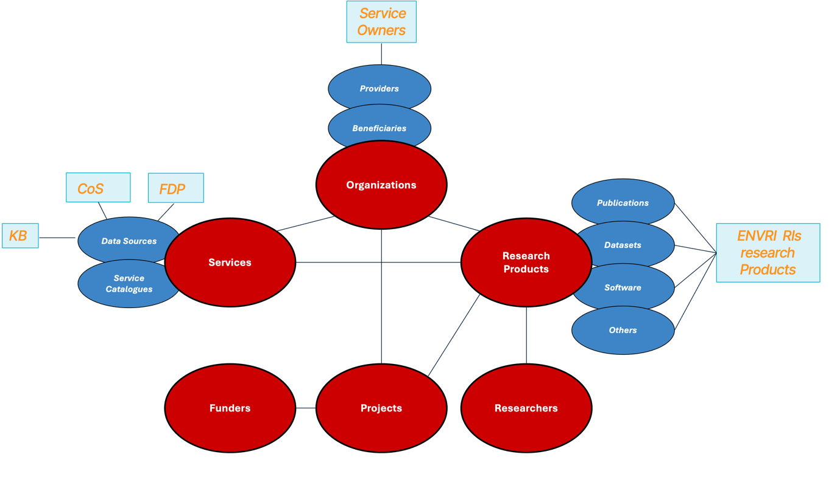
Fig 1. EOSC resources data model and mapping to ENVRI Hub resource types

Following this model, the “data sources” are identified as the entities representing both the ENVRI Hub Catalogue of Services (CoS) and the Fair Data Points (FDP). Data sources are a type of service representing aggregations of research products, mostly datasets for ENVRI Hub CoS and FDP. Accordingly, we outline the metadata requirements necessary to onboard a data source and its associated research products.

Providers Profile
Prior to onboarding any type of services or data sources in this case, a service owner must be registered as a provider. At the time of writing, the data model is under review to accommodate the integration of EOSC Nodes. Providers are required to complete administrative details as specified in the EOSC Provider Profile v5.0 [REF]
https://eosc-provider-profile.readthedocs.io

Service Profile
Data sources identified as KB, CoS and FDP in ENVRI Hub must be registered in accordance with the EOSC service profile. https://eosc-service-profile.readthedocs.io/en/5.0/
While the registration of these services in a testing environment may not require a fully rigorous onboarding process—such as the provision of access or privacy policies—these elements are mandatory in operational environments. Therefore, it is recommended to define them already during the staging phase.

Research Products
Individual research products aggregated within a data source must comply with the EOSC-IF Guidelines for Data Sources to onboard Research Products.
These guidelines support the onboarding of research product, including datasets, made available through data sources using the OAI-PMH protocol and following DataCite-based metadata schemas. [REF] https://guidelines.openaire.eu/en/latest/

5.2 Implementation steps:
We propose the following key steps for integrating the ENVRI Hub into the EOSC ecosystem, with consideration on the limited available budget:
- Technical Interoperability: Ensure seamless technical integration with the EOSC Core and other relevant EOSC services through adherence to common standards and APIs.
- Metadata Alignment: Further align the ENVRI Hub's metadata schema with emerging EOSC metadata standards to enhance interoperability across different scientific domains.
- Service Integration: Explore opportunities to integrate ENVRI Hub functionalities with other EOSC services, such as data analytics platforms and visualization tools.
- Governance and Sustainability: Establish clear governance mechanisms and a sustainable funding model for the ENVRI Hub within the EOSC framework, leveraging the collective strength of the ENVRI community.
- User Engagement and Training: Develop training materials and outreach activities to promote the use of the ENVRI Hub within the broader EOSC user community.
6. Expected Impact and Benefits for EOSC Users:
Integrating the ENVRI Hub into EOSC will provide significant benefits for EOSC users:
- Simplified Access to Environmental Data: Researchers from various disciplines will gain easy access to a wealth of crucial environmental information.
- Enhanced Research Efficiency: Streamlined data discovery will save researchers time and effort, allowing them to focus on analysis and innovation.
- Increased Potential for Cross-Disciplinary Collaboration: The ability to easily discover and integrate environmental data with resources from other domains will foster new research collaborations.
- Support for Addressing Global Challenges: Access to comprehensive environmental data provided by environmental RIs is crucial for tackling pressing global challenges such as climate change, biodiversity loss, and pollution.
- Contribution to Open Science Principles: By utilizing the ENVRI Hub, users will be contributing to and benefiting from the principles of open and reproducible science.

7. Conclusion:
The ENVRI Hub search engine represents a mature, community-driven, and FAIR-aligned service that can significantly enrich the EOSC ecosystem. Its integration will provide EOSC users with seamless access to a vast and diverse landscape of environmental research assets, fostering interdisciplinary collaboration and accelerating scientific discovery in critical areas. The ENVRI community is committed to working closely with the European Commission and other EOSC stakeholders to ensure a successful and impactful integration.

The ENVRI Hub core services represent a mature, community-driven, and FAIR-aligned services poised to significantly enrich the EOSC ecosystem. Its integration will provide EOSC users with seamless access to a vast and diverse landscape of environmental research assets, fostering interdisciplinary collaboration and accelerating scientific discovery in critical areas. To ensure the long-term success and sustainability of this contribution, we propose a robust multi-layered, smart and science driven governance structure that leverages the expertise within the ENVRI community and aligns with EOSC principles. Furthermore, a hybrid business model, pursuit of EOSC core funding, and exploration of project-based opportunities, will underpin the ENVRI Hub's continued operation and development. The ENVRI community is committed to working closely with the European Commission and other EOSC stakeholders to ensure a successful and impactful integration, establishing the ENVRI Hub as a cornerstone of the European Open Science Cloud for years to come.

8. Next Steps:
We are eager to discuss these proposals for governance and a business model in more detail with the European Commission and relevant EOSC stakeholders and the ENVRI board of Directors. We believe that a collaborative approach will be key to establishing the ENVRI Hub as a cornerstone of the European Open Science Cloud.

Appendix:

EOSC ENVRI NODE
V.2 Draft Document
__________________________________________________________________________________________________________________________________________________

Purpose of the ENVRI EOSC Node
The EOSC ENVRI Node serves as the coordinated interface between the ENVRI Science Cluster and the European Open Science Cloud (EOSC). It ensures that the services and data from environmental research infrastructures are used in EOSC, and that EOSC tools are useful for environmental scientists.

Core Building Principles
· Based on ENVRI-hub
· Researcher-centric design
· FAIR-by-design services and data
· Interoperability and cross-domain integration
· Transparent and inclusive governance
· Long-term sustainability (need the business model development)
Governance Model Overview
The Node is coordinated through a structured set of Working Groups (WGs), each responsible for a core functional area. Overall leadership and strategic direction are provided by the Head of Node and the Governance & Liaison WG.
Governance Roles and Responsibilities
Head of Node
· Provides strategic leadership and coordination across all WGs
· Main point of contact with EOSC-A, EC, other clusters and external forums
· Chairs the Governance & Liaison WG
· Ensures delivery of Node objectives and alignment with EOSC policy and architecture
· Answers to ENVRI Board
Governance & Liaison WG
· Supports the Head of Node
· Oversees internal coordination, progress tracking, and strategic adjustments
· Ensures coherence and collaboration among all WGs
· Facilitates alignment with EOSC-A, EC, and other Science Clusters
· Includes a Node secretariat & Communications (?)
· Major decisions are made within the Governance WG, with input from WG leads

Science WG
· Led by Chief Scientist
· Identifies and prioritizes cross-RI scientific use cases
· Ensures ENVRI’s scientific relevance in EOSC
· Interfaces with research communities and RI science boards
· Feeds scientific priorities into Tech, Service and Engagement
Technological Development & Interoperability WG
· Coordinates technical development, standards, and tools
· Coordinates technical alignment with EOSC-Core
· Promotes interoperability across RIs and alignment with EOSC-Core and EOSC-IF.
· Leads FAIR implementation and supports technical onboarding of services
· Works closely with the Service WG
Architecture, Service Integration & Operations WG
· Focuses on actual service delivery through the EOSC (connections to EU Node and other relevant nodes)
· Oversees onboarding of services into EOSC ENVRI Node
· Ensures quality of service, usability, and operational coherence
· Manages helpdesk, monitoring and technical service support processes
· Works with Tech WG and Engagement WG
· Definition of the architecture of the EOSC ENVRI Node
User Engagement & Training WG
· Gathers researcher feedback & requirements
· Co-designs services with users and research communities
· Develops training materials and promotes capacity building
· Promotes uptake
Policy & Sustainability WG
· Addresses licensing, legal, and ethical issues
· Ensures compliance with EOSC Rules of Participation
· Manages the ENVRI Node RoP
· Develops long-term sustainability strategies for Node services
· Works with funders and policy frameworks
· MoU or other form of cooperation document among ENVRI RIs (part of sustainability)

